

Manufacturing Downtime Analysis

Project Report

Digital Egypt Pioneers Initiative (DEPI)

Google Data Analysis Specialist Track

CAI2_DAT1G6

Contributors

Abd Al-Rahman Mohamed Amin

Mohamed Shebl Azab

Omar Mohamed Shebl

Ahmed Mohamed

November 2024 – April 2025

Table of Contents

Introduction………………………………………………………………………………………………………………………..……………………………………………………2

Executive Summary 3

Phase I: Data Cleaning and Preprocessing 4

Data Overview 4

Data Tables Normalization 5

The Data Cleaning Process 6

Data Modelling 7

Tools and Technologies Used 7

Phase II: Exploratory Data Analysis 19

Analysis Questions 19

Key Findings 56

Deliverables 56

Phase III: Forecasting Analysis 57

Forecasting Questions 57

Key Findings 57

Deliverables 57

Phase IV: Visualization and Final Presentation 63

Deliverables 63

Recommendations 65

Contributors 66

Appendices 67

Appendix I: Exploratory Analysis Visualizations 67

Appendix II: Tableau Dashboard Screenshots 70

# 

Manufacturing Downtime Analysis

# Introduction:

# Problem & Objective

# The Problem

We have witnessed an increase in production line stoppages, which has negatively impacted productivity levels and operational costs.

# The Objective

To understand the underlying causes of these stoppages, identify critical pain point, and propose practical solutions to improve overall performance.

# Executive Summary

This project investigates the factors causing production downtime in a soda drinks company. Using data cleaning, modeling, exploratory analysis, and forecasting, we identify the major contributors to downtime and predict future trends. The findings provide actionable insights to optimize operations and minimize downtime.

The project follows a structured data analysis approach. First, raw operational data is cleaned and preprocessed to ensure accuracy. A data model is then built to establish relationships between key variables affecting downtime. Exploratory analysis is conducted to uncover patterns, followed by forecasting models that predict future downtime trends. Finally, a Tableau dashboard visualizes the findings for decision-making.

The dataset consists of downtime records collected over a period of 5 days. The dataset included categories for causing factors, details on the batches produced such as production date, and details on the products produced by the company such as product flavors and package sizes. This allowed analysis of downtime by product features and causing factors.

The analysis found that five out of possible twelve causing factors contributed to 80% of the downtime. Machine adjustments were the primary cause behind downtime accounting for 23.92% of the downtime during the observed period. Forecasting analysis revealed that downtime is expected to drop by 33.22% within 7 days.

To mitigate production downtime, it is recommended that the company improves staff training on operating the machinery and troubleshooting, and implement a preemptive maintenance schedule. The Tableau dashboard provides real-time insights to help management track downtime patterns and take proactive measures.

# Phase I: Unpivoting Data (Data Transformation and Preprocessing(

Data Transformation is a crucial step before analysis because raw data often contains errors, inconsistencies, and missing values that can lead to inaccurate insights. By removing duplicates, handling missing data, correcting errors, and standardizing formats, data cleaning ensures the dataset is reliable and consistent.

## Data Overview

The raw dataset contains records on produced batches and downtime caused by different factors. The table below describes the dataset in details:

|  |  |  |
| --- | --- | --- |
| **Entity** | **Entity Type** | **Description** |
| **Downtime Factors** | **Dimension Table** | **Includes details on each downtime factor.** |
| Factor | Attribute | Unique identifier for each downtime factor. |
| Description | Attribute | Descriptive text for each factor. |
| Operator Error | Attribute | Whether a factor involves a human error. |
| **Line Downtime** | **Fact Table** | **Records downtime caused by each factor in production batches.** |
| Batch | Attribute | Unique identifier for produced batches. |
| Factor | Attribute | Downtime minutes for each factor in a wide format (12 columns). |
| **Line Productivity** | **Fact Table** | **Records details on each of the batches produced.** |
| Batch | Attribute | Unique identifier for the batch. |
| Date | Attribute | Production date. |
| Product | Attribute | Unique identifier for products. |
| Operator | Attribute | Name of the operator in charge during batch production. |
| Start Time | Attribute | Time at which batch production started. |
| End Time | Attribute | Time at which batch production ended. |
| **Products** | **Dimension Table** | **Includes details on the products produced by the company.** |
| Product | Attribute | Unique identifier for products. |
| Flavor | Attribute | Soda flavor of the product e.g., cola, lemon …etc. |
| Size | Attribute | Pack volume in milli liters. |
| Min Batch Time | Attribute | Minimum time required to produce a single batch without delay. |

## 

## Data Tables Normalization

Data table normalization is the process of organizing a database to reduce redundancy and improve data integrity. It involves structuring tables according to a series of normal forms (NF), such as First Normal Form (1NF), Second Normal Form (2NF), and so on. The process eliminates duplicate data, ensures logical dependencies, and minimizes anomalies in data insertion, updating, and deletion. Normalization was applied to each of the provided tables to the third normal form (3NF):

* First Normal Form (1NF): ensure no repeating groups or multivalued attributes and that each column contains atomic values.
* Second Normal Form (1NF): ensure all non-key attributes are fully functionally dependent on the entire primary key.
* Third Normal Form (3NF): eliminate transitive dependencies so non-key attributes depend only on the primary key.

**Findings:**

1. The Line Downtime table violated 1NF because downtime factors are stored as column headers. Microsoft Excel Power Query’s unpivot columns feature was used to convert the table into a long format with only 3 columns: batch, factor, and downtime.
2. The Products table violated 3NF and was found to have a transitive dependency where Min Batch Time depended on Size rather than the primary key. Min Batch Time and Size were separated in a new table (Products Details) to resolve this issue.

## The Data Preparation & loading

Python was used to ensure that each table was clean and ready for analysis:

1. Check for missing values: No value was found to be missing in any of the tables.

1. # Check for null values in each column

2. line_prod.isnull().sum()

1. Check that the number of unique IDs is equal to the number of rows in the table: all rows were found to have unique IDs in all the tables.

1. # Count the number of unique batch IDs

2. # The number of unique batch IDs should be equal to the number of rows in the data frame

3. line_prod.Batch.nunique()

1. Check for duplicate records: no duplicate records were found in any of the tables.

1. # Find the number of duplicate records

2. line_prod.duplicated().sum()

1. Check data type and formatting consistency in each column

1. # Check that all End Time values are of the type datetime.time

2. line_prod["End_Time"].apply(lambda x: isinstance(x, datetime.time)).all()

The data types of values in the End Time column were not consistent. The following code was used to isolate rows where the type was not datetime.time where only one row was found to have a datetime.datetime data type:

1. # Find values in End Time that are not of the type datetime.time

2. line_prod[line_prod["End_Time"].apply(lambda x: not(isinstance(x, datetime.time)))]

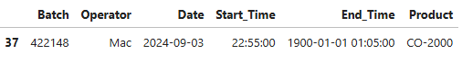

The time component of was extracted and used to overwrite the value at index 37:

1. # Extract the time component and rewrite the value

2. line_prod.loc[37, "End_Time"] = line_prod.loc[37, "End_Time"].time()

## Data Modelling

Microsoft Excel Power Pivot was used to construct a calendar table, and build a relational model to ensure efficient querying and visualization. The following entity relationship diagram (ERD) summarizes all the relations in the model:

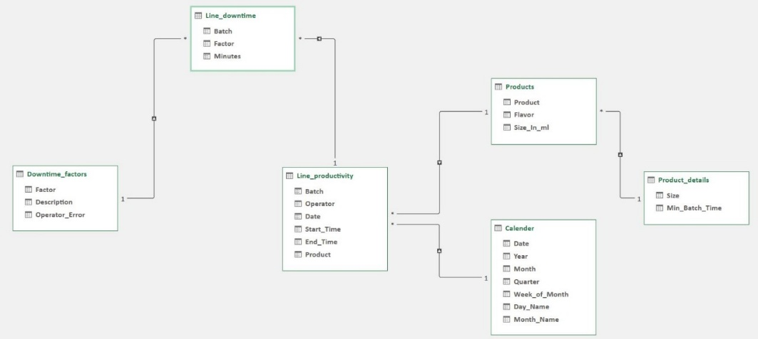

## Tools and Technologies Used

|  |  |  |
| --- | --- | --- |
| 1. Microsoft Excel. | 1. Power Query. | 1. Power Pivot. |
| 1. Python (packages: Pandas, NumPy, and datetime).   6. Tableau | | 1. Microsoft SQL Server. |

## Deliverables

After data cleaning, the dataset was analysis-ready, with standardized variables and improved data integrity. The preprocessing steps are documented in a Jupyter Notebook for reproducibility.

* This includes the integration and implementation of tables on Excel spreadsheets, SQL databases, Python scripts and Tableau :
* **Tables on Excel :**

1. Downtime_factors table:



1. Line_downtime table:

Before/After table snippets:

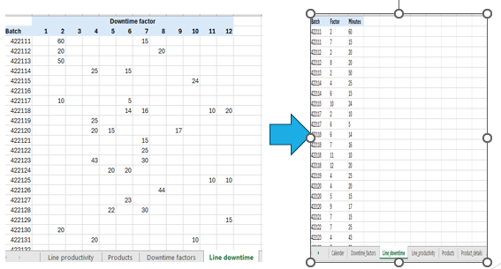

1. Line_productivity table:



1. Products table:



1. Product_details table:



1. Calender table:



* Tables on SQL Server :

A database was created on SQL server , and all the necessary tables have been created within it.

1. Downtime_factors table:

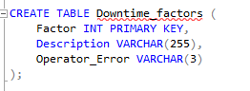

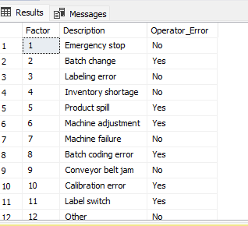

1. Line_downtime table:

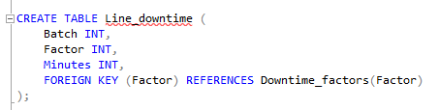

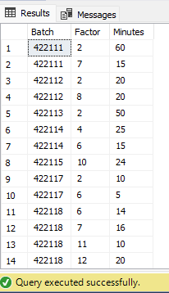

1. Line_productivity table:

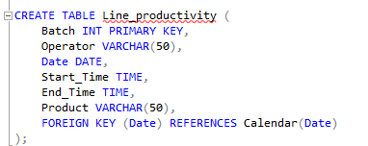

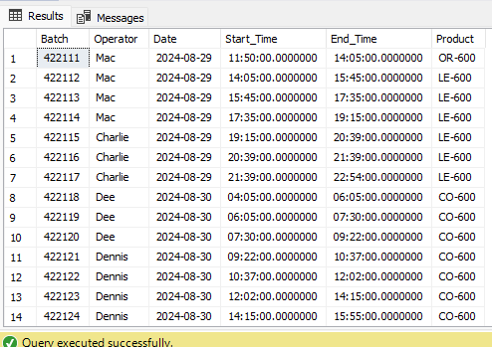

1. Products table:

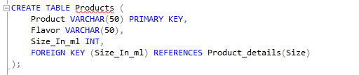

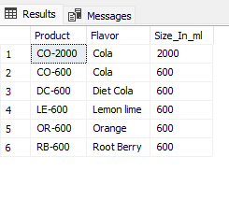

1. Product_details table:

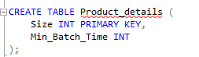

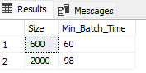

1. Calender table:

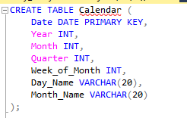

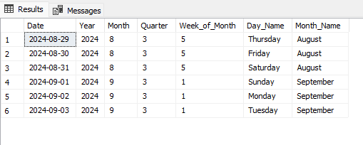

* **Import Packages and Load Data on Paython Jupyter notebook :**

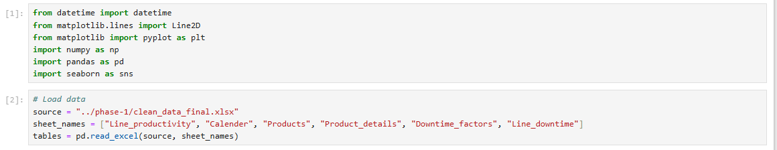

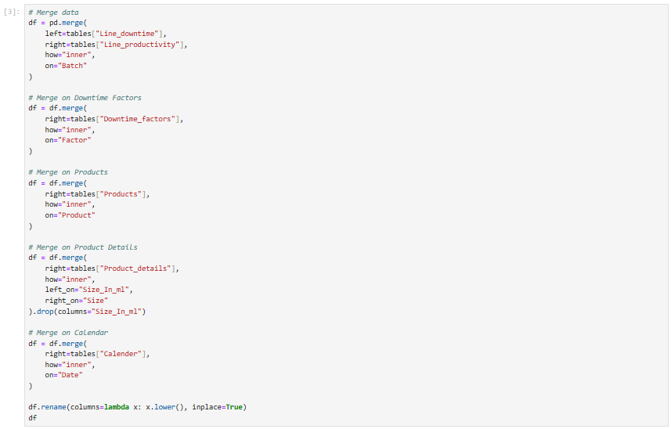

# 

* **Import Data source on Tableau** :

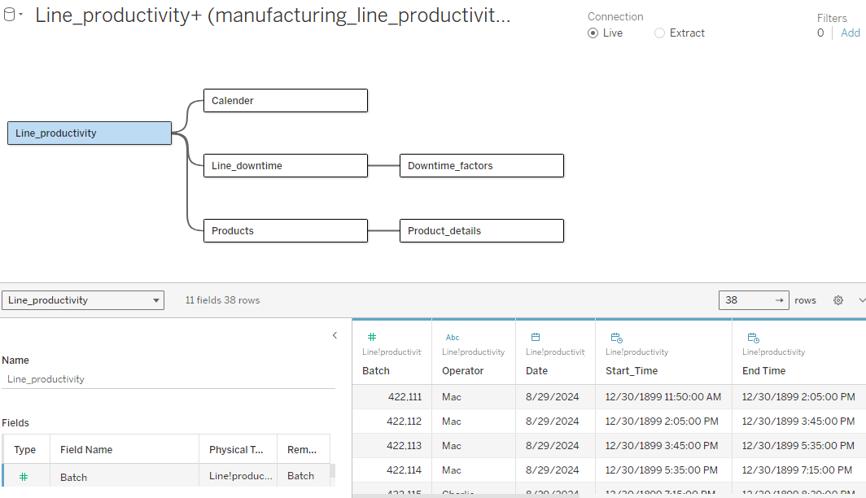

# Phase II: Exploratory Data Analysis

The exploratory analysis was conducted to identify patterns and underlying factors contributing to production downtime. This phase helped uncover the most frequent failure type, and time-based trends.

## Analysis Questions

**Analysis of Downtime by Causes**

1. Which Factors Contribute the Most to Downtime?
2. Are some downtime factors more frequent than others?
3. Does operator error cause more downtime than other causes?
4. Which Operator Causes More Downtime and through which factors?
5. Does Downtime Occur at Higher Rates for in Products with Certain Flavors?
6. How Does Product Size Impact the Occurrence of Downtime?
7. Does product spill occur more often with products of large volume?
8. Which Products Experience More Downtime?

**Time-Series Analysis**

1. How does downtime vary overtime?
2. How Does Downtime Vary by Work Shifts?
3. How much production time was lost due to downtime?

**Impact of Downtime on Production Rates**

1. How does down time impact productivity?

# Cause Analysis

1. **Which Factors Contribute the Most to Downtime?**

* Tables: Downtime Factors, Line Downtime.
* Visualizations: Draw a Pareto chart that shows how much each factor contributes to downtime, and factors that collectively contribute to 80% of downtime (vital few).
* Steps:
  1. Join Downtime Factors and Line Downtime.
  2. Group factors by the sum of downtime minutes.
  3. Sort data by total downtime minutes in a descending order.
  4. Calculate downtime contributed by each factor as a percent of the total, and a cumulative percent of total.
  5. Draw a pareto chart.

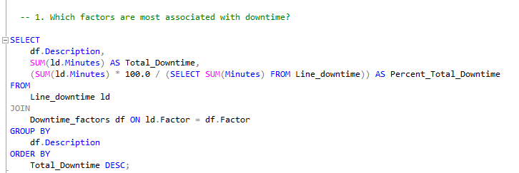

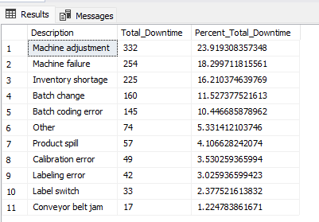

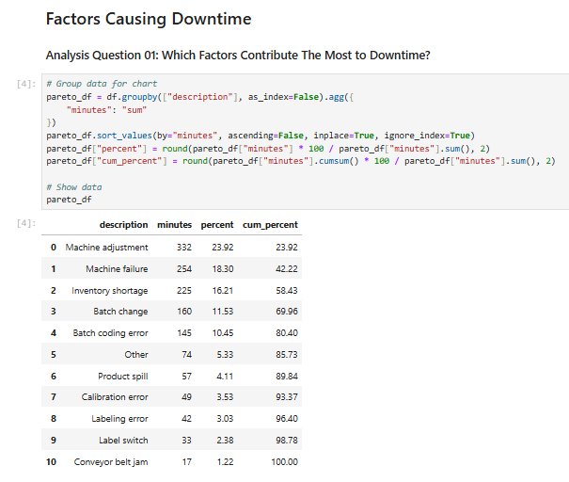

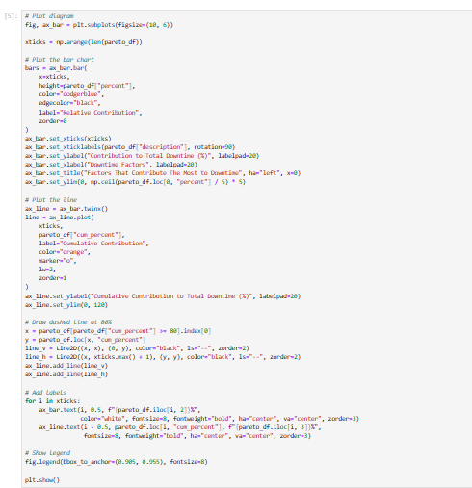

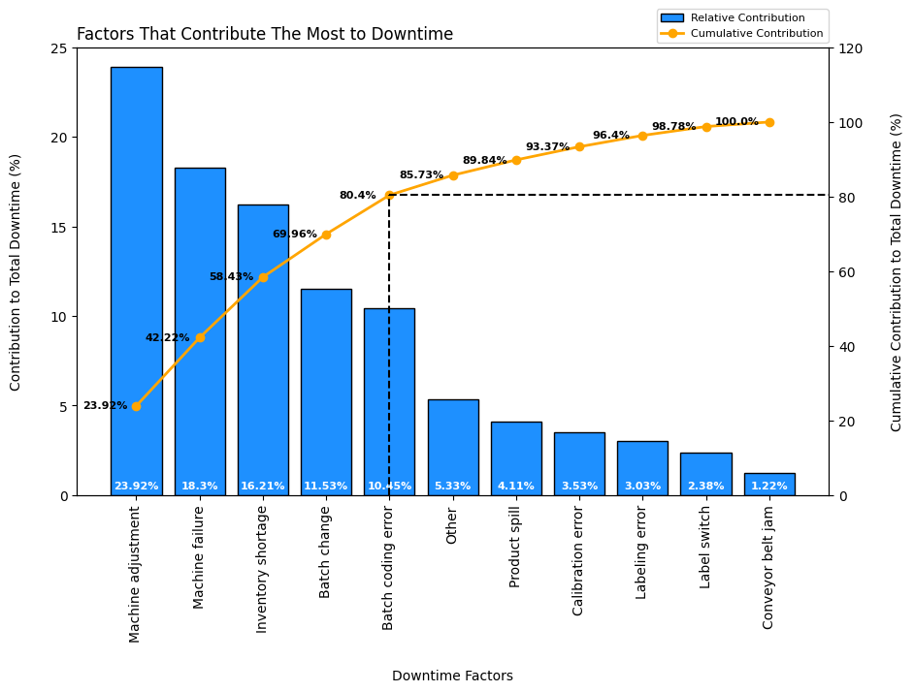

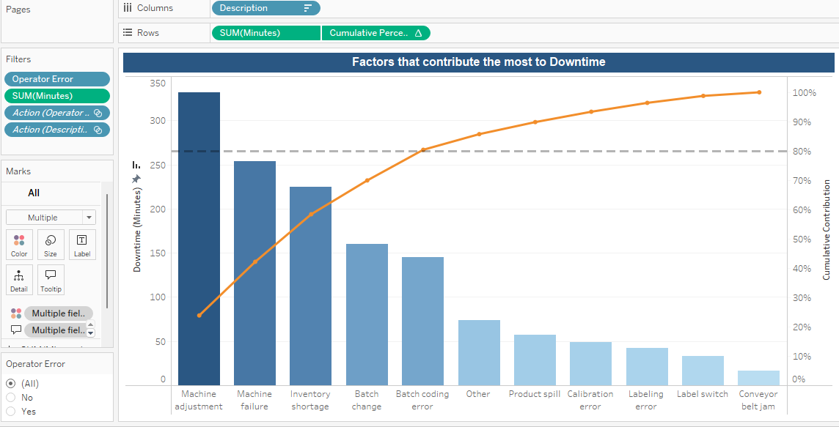

1. **Are some downtime factors more frequent than others?**

* Tables: Downtime Factors, Line Downtime.
* Visualization: Scatter chart.
* Steps:
  1. Join Line Downtime and Downtime Factors.
  2. Group factors by the sum of downtime minutes and their frequency of occurrence using any non-null column.
  3. Draw a scatter chart with total downtime minutes on the x-axis and the frequency of occurrence on the y-axis.

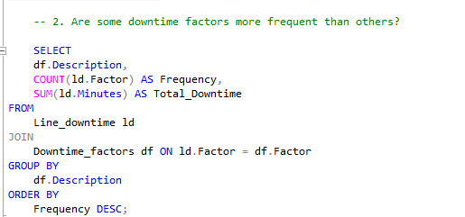

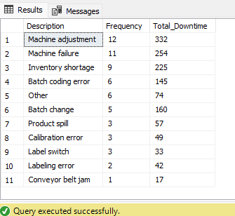

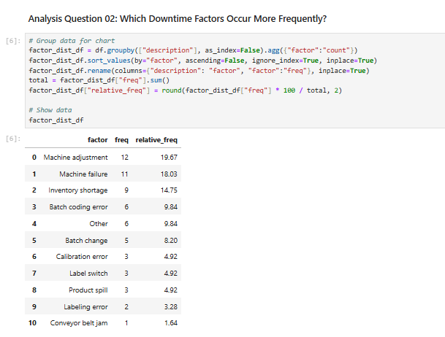

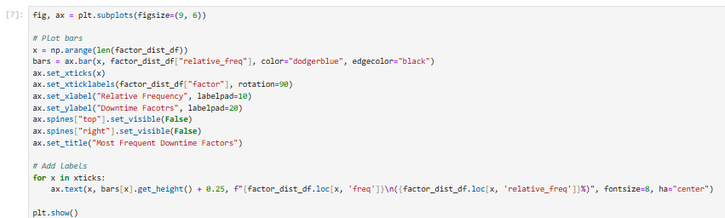

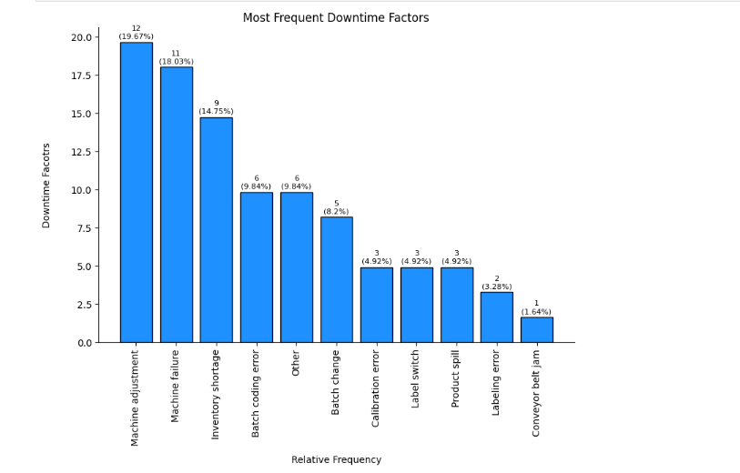

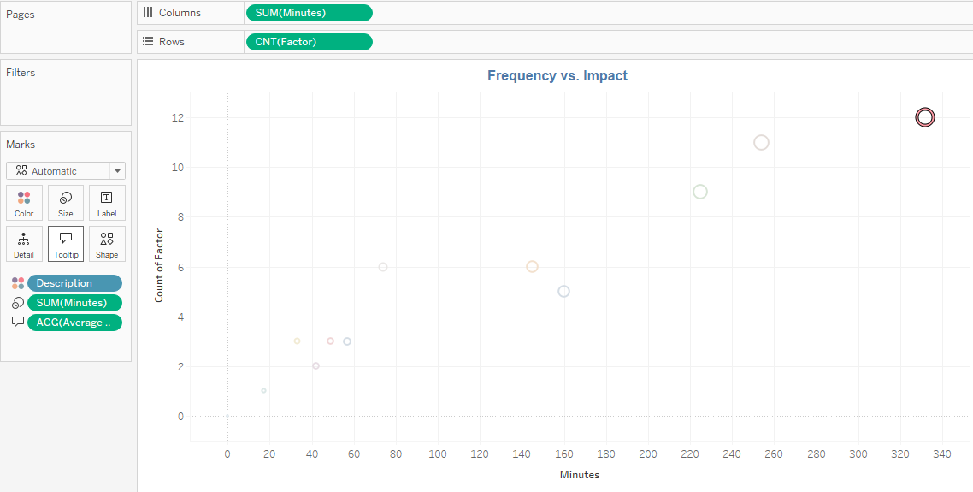

3. Does operator error cause more downtime than other causes?

• Tables: Downtime Factors, Line Downtime.

• Visualizations: Pie chart.

• Steps:

a. Join Downtime Factors with Line Downtime.

b. Plot operator error and the sum of downtime minutes in a pie.

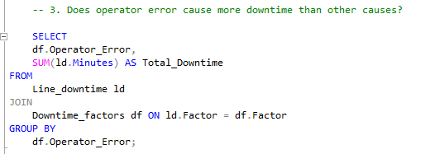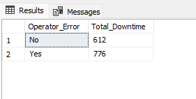

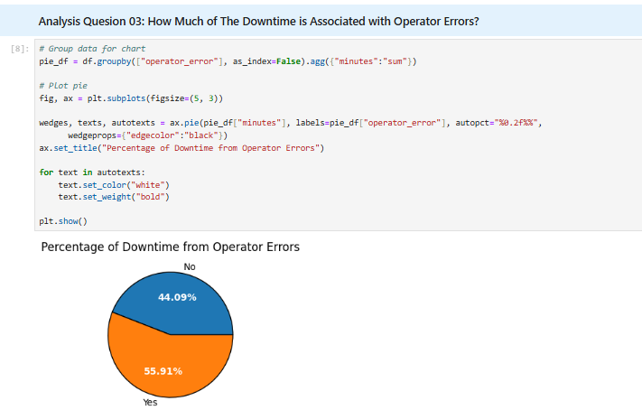

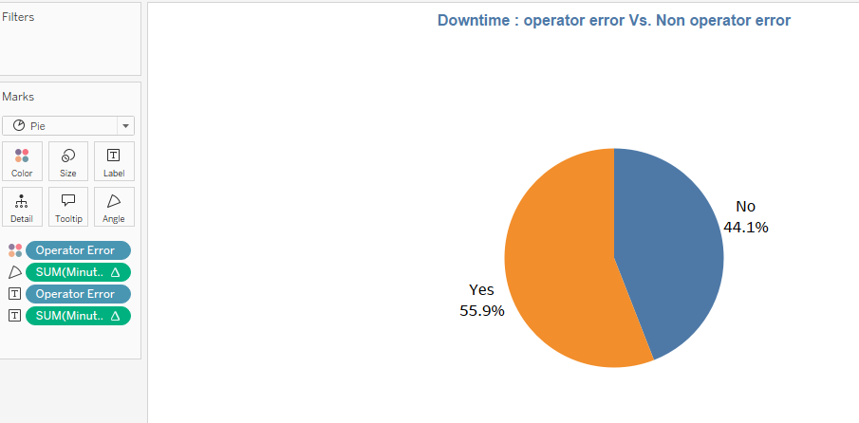

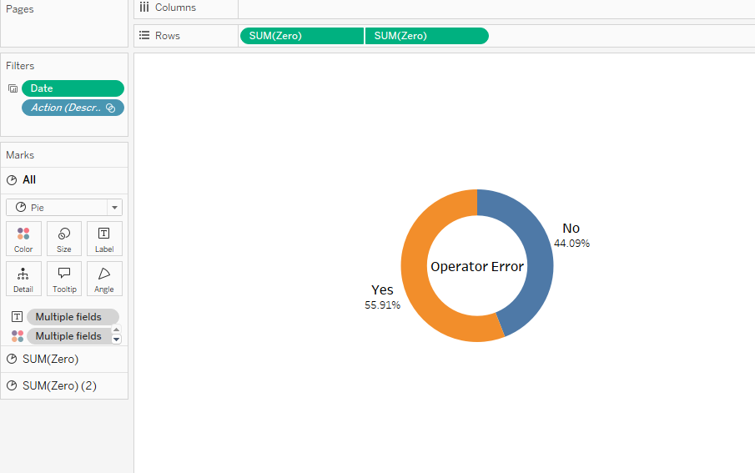

**4.Which operator causes more downtime and through which factors?**

* Tables: Downtime Factors, Line Downtime, Line Productivity.
* Visualizations: Stacked bar chart that compares downtimes caused by each operator, and breaks downtime by factors for each operator.
* Steps:
  1. Join tables.
  2. Plot the stacked bar.

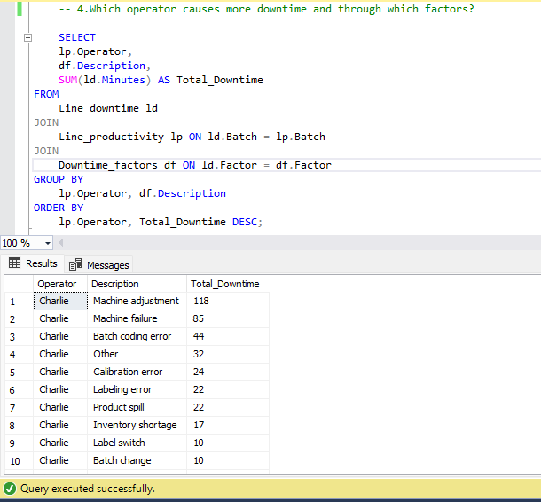

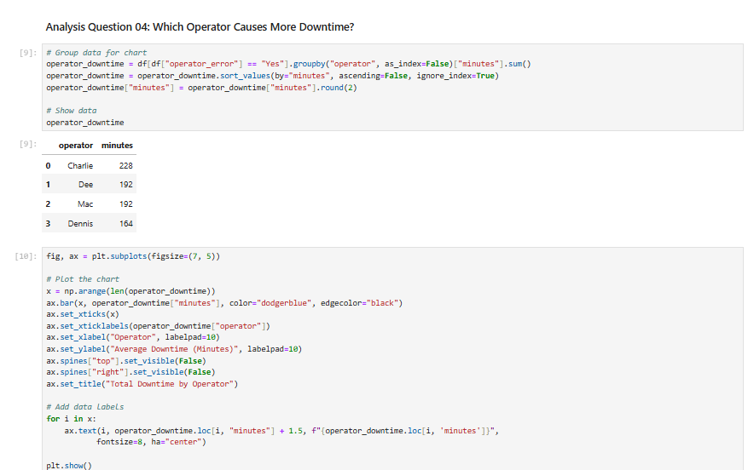

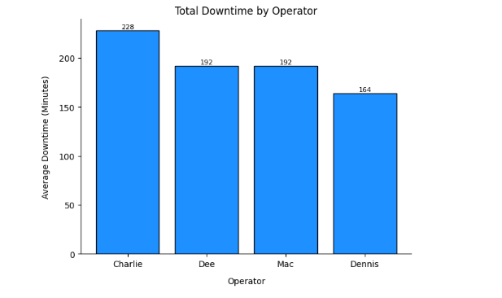

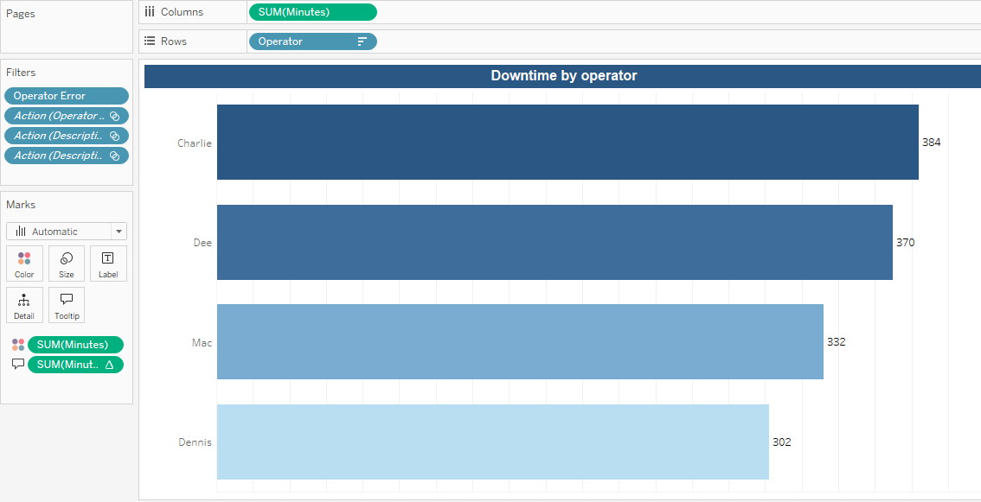

**5.Does downtime occur at higher rates for in products with certain flavors?**

* Tables: Line Downtime, Line Productivity, Products.
* Visualization: Bar chart showing average downtime for each flavor.
* Steps:
  1. Join tables.
  2. Plot product flavors by average downtime in minutes.

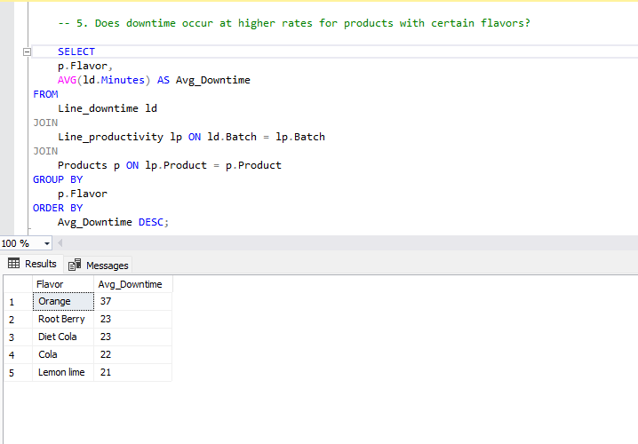

## 

## 

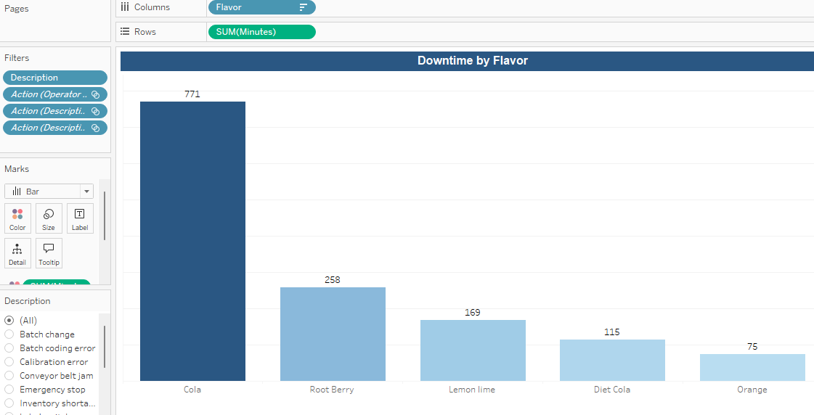

**6. How does product size impact the occurrence of downtime?**

* Tables: Line Downtime, Line Productivity, Products.
* Visualizations: Bar chart showing average downtime for each product size.
* Steps:
  1. Join tables.
  2. Plot product size and average downtime in minutes.

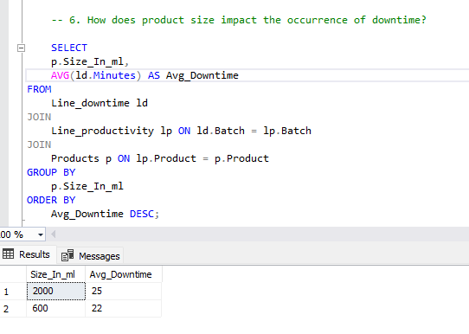

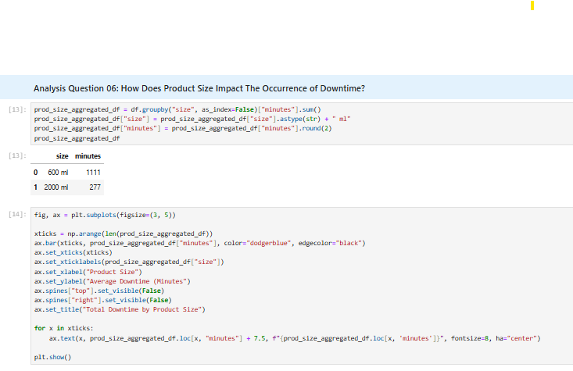

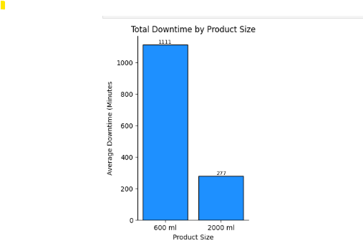

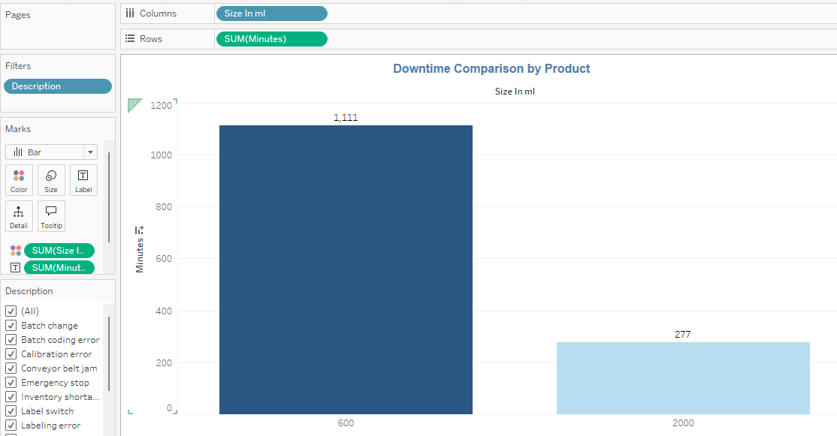

1. **Does product spill occur more often with products of large volume?**

* Tables: Downtime Factors, Line Downtime, Line Productivity, Products.
* Visualization: bar chart showing downtime due to product spill in different product sizes.
* Steps:

1. Join data.
2. Filter by product spill.
3. Plot the graph.

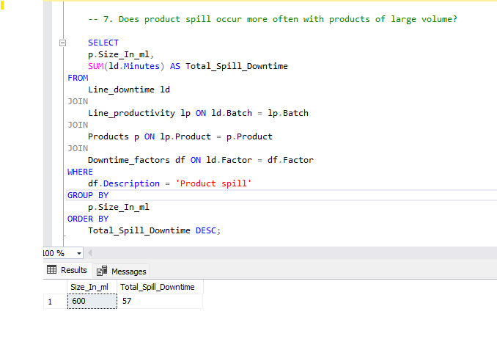

## 

## 

1. **Which products experience more downtime?**

* Tables: Line Downtime, Line Productivity.
* Visualization: bar chart showing total Downtime for each product.
* Steps:
  1. Join data.
  2. Plot product by sum downtime in minutes.

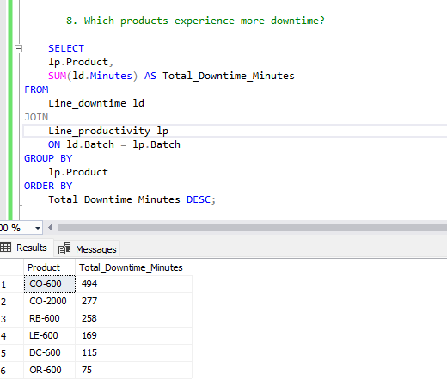

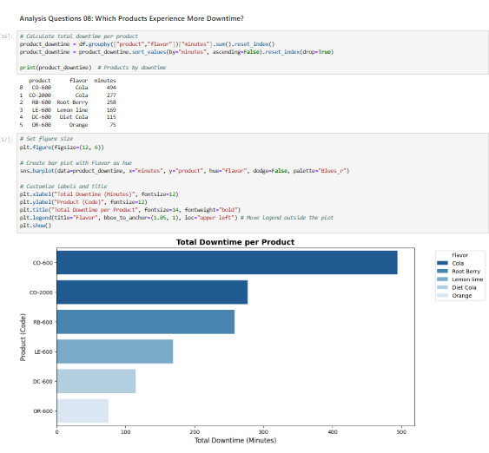

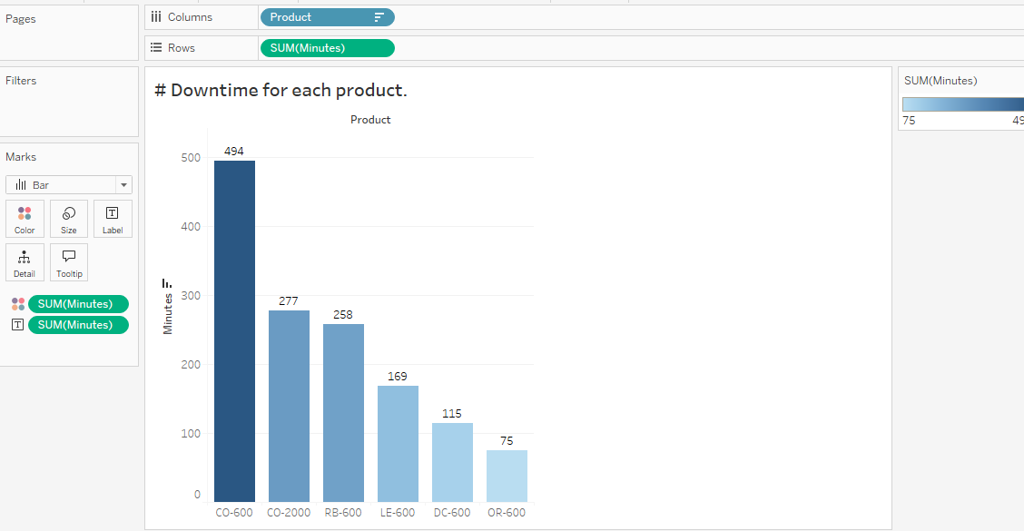

# **Time Analysis**

Time analysis is based on batch start times.

1. **How does downtime vary overtime?**

* Tables: Line Downtime, Line Productivity.
* Visualizations: Line chart showing total downtime by day.
* Steps:
  1. Join tables.
  2. Plot chart.

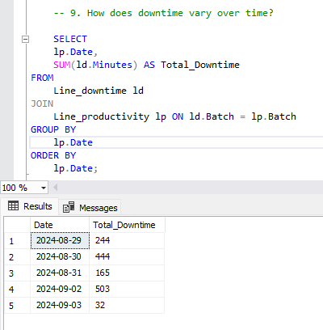

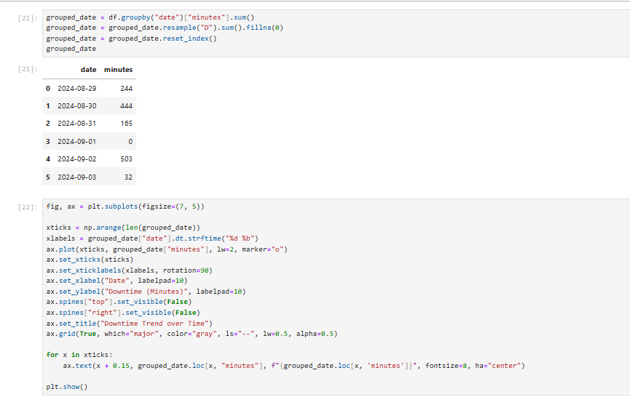

## 

## 

1. **How does downtime vary by work shifts?**

* Tables: Line Downtime, Line Productivity.
* Visualizations: Bar chart showing total downtime for each work shift.
* Steps:

1. Join tables.
2. Add a new column for work shifts (Night: 00 – 08, Morning: 08 – 16, Afternoon: 16 – 24).
3. Plot bar chart.

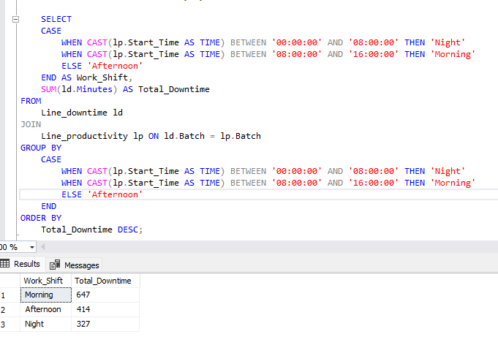

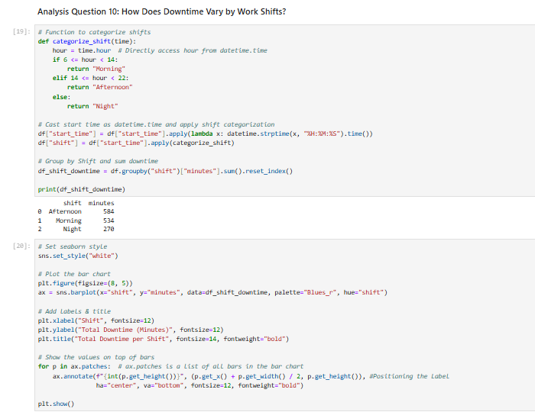

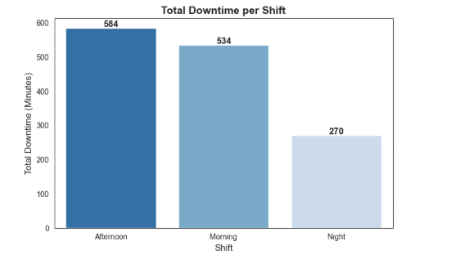

## 

1. **How much production time was lost due to downtime?**

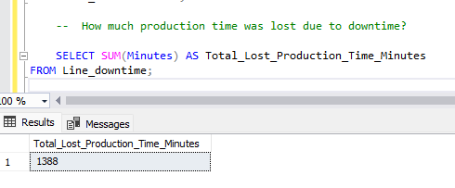

Hours=1388 / 60 = 23.13 hours

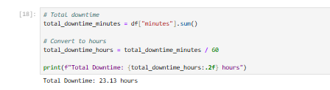

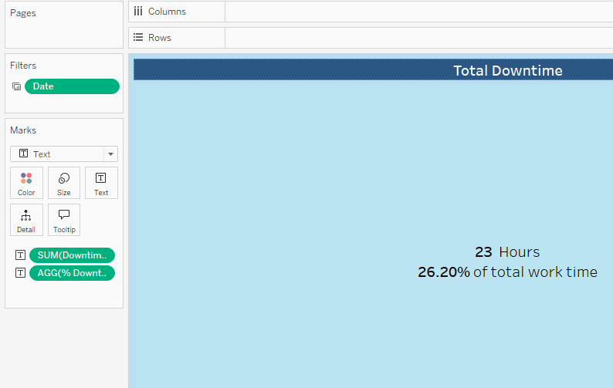

# Impact Analysis

1. **How does down time impact productivity?**

* Tables: Line Downtime, Line Productivity
* Visualizations: Line plot comparing the number of produced batches per hour to total downtime.
* Steps:

1. Join tables.
2. Group by days, count of batches divided by day work time (last end time – first start time in hours), sum of downtime.
3. Plot graph.

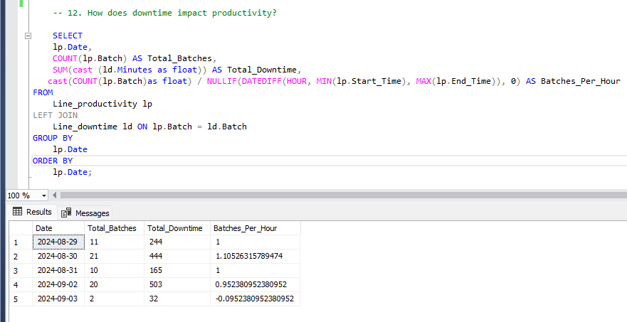

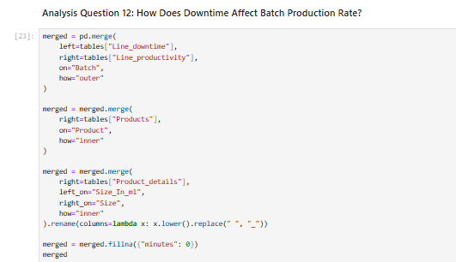

## 

## 

## 

## 

## Key Findings

1. Five factors contributed to 80% of the total downtime, and these are:

* Machine adjustment.
* Machine failure.
* Inventory shortage.
* Batch change.
* Batch coding error.

1. Most operators require training on machine adjustments.
2. Approximately 80% of the downtime due to inventory shortage occurred with cola-flavored products.
3. Among all operators, only Mac requires training on batch changing.
4. Approximately 87.5% of the downtime due to batch change occurs with products that are not cola-flavored. This might be due to a larger number of batches produced of cola products (62.86% of the total number of batches) which means production switches to cola less often compared to other flavors.
5. All operators contribute to downtime due to batch coding errors.
6. Downtime was highest during morning shifts.

## Deliverables

By the end of this phase, all analysis questions have been formulated, and key insights have been noted. The exploratory analysis was documented in a Jupyter notebook for reproducibility. Also, an initial design for the final dashboard has been drafted.

# Phase III: Forecasting Analysis

Forecasting analysis is the process of using historical data, statistical models, and machine learning techniques to predict future outcomes. In this phase, changes in downtime trends over time was forecasted using Prophet, a python package for predictive modelling. The model was used to predict downtime and the number of produced batches in the next day of operation. Data from the last day of operation was excluded from the historical data frame that was fed to the model as its low total downtime skews the results.

## Forecasting Questions

1. How is downtime expected to change over the next day of operation?
2. Can changes in downtime be predicted with certainty based on the current data?

## Key Findings

1. Downtime was expected to decrease by -2.25% within the next day of operation.
2. The number of produced batches was expected to drop by -0.79% within the next day of operation.
3. The model predicted with a very low level of certainty probably because the size of the historical data is very small.

## Deliverables

Changes in downtime were forecasted but with a low level of certainty. The forecasting analysis was documented in a Jupyter notebook for reproducibility.

1. 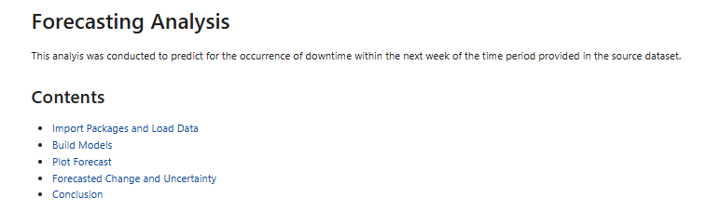

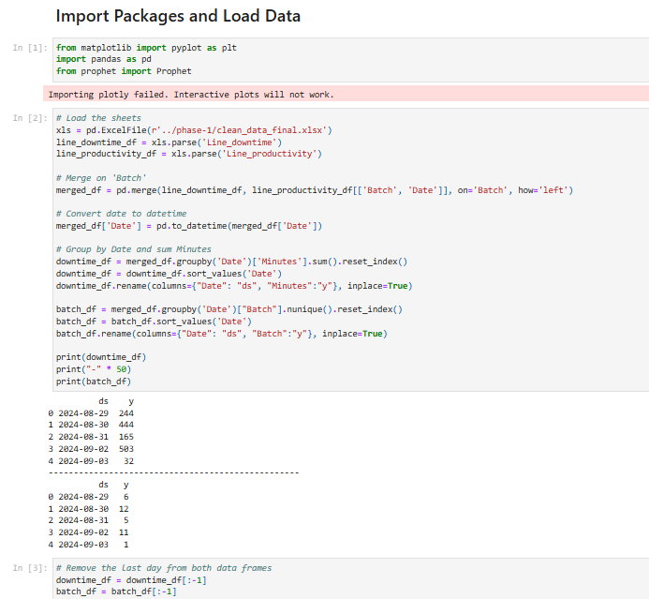

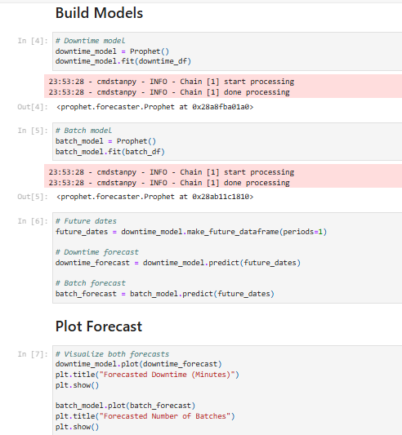

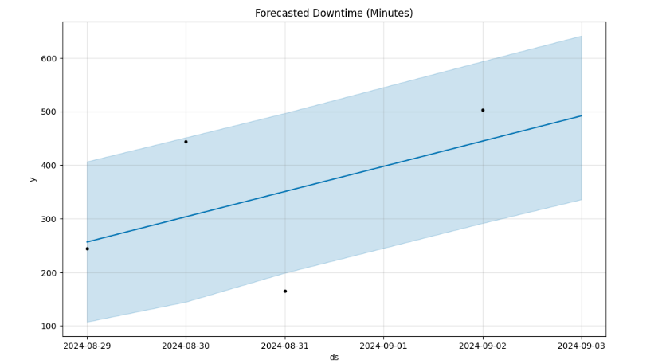

# 

# 

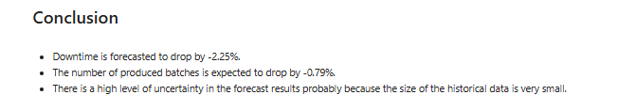

# Phase IV: Visualization and Final Presentation

Data visualization is the graphical representation of data and information using charts, graphs, maps, and other visual tools to help communicate complex insights clearly and effectively. It simplifies the understanding of large datasets, making patterns, trends, and outliers more visible and easier to interpret. In this project’s context, data visualization is important to monitor downtime in real time which allows proactive handling of future downtime events.

## Deliverables

Tableau was used to graphically present key insights discovered in the exploratory analysis phase. The graphs were organized in a dashboard that allows users to easily monitor the causes behind downtime, and the types of products most associated with downtime. Tableau was also used to build a dashboard to monitor how downtime changes over time. Moreover, a Microsoft PowerPoint presentation was built to present an overview of all the efforts made in the project.

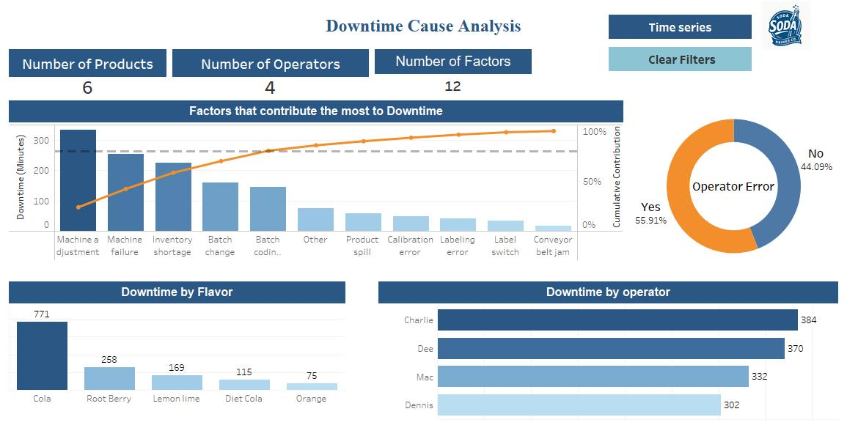

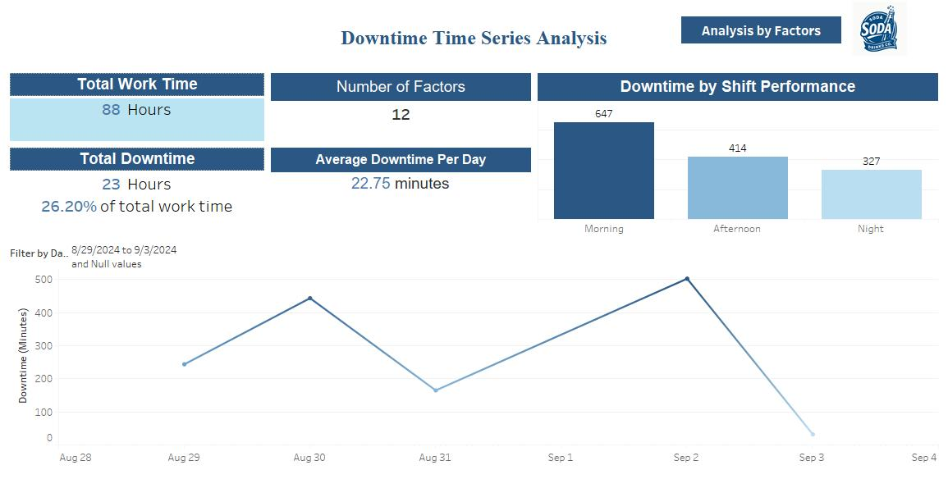

# Recommendations

* The company should provide regular training sessions to operators to improve operator familiarity with the machines they operate on, and to equip them with the basic troubleshooting skills that can help them resolve machine failure issues. Additionally, the training should equip operators with enough knowledge about the batch coding process and the machines involved e.g., printers or labelling machines.
* The company produces cola-flavored soda at a higher rate compared to other flavors (63.16% of the produced batches were cola-flavored products). This makes the ingredients of the cola formula more prone to shortages and explains why 80% of the downtime due to inventory shortage occurred in batches of cola-flavored products. The company should re-visit its purchasing strategy and refine it to match its production schedule.
* Downtime from batch changes was noted to be longer for products that are not cola-flavored, suggesting that it occurs when switching production to products that are less frequently produced. The company should invest in obtaining spare parts for parts of the production line that require cleaning before switching to different flavors to avoid contamination e.g., mixers, to eliminate such delay.
* The company should consider upgrading the machinery software to introduce features like preset production settings. Settings can be set by a production expert which reduces operator involvement with machine adjustments. Preset settings can also help with reducing the time taken to change machine settings when switching production between different products.

# Contributors

Abd Al-Rahman Mohamed Amin

|  |  |
| --- | --- |
| Email with solid fill | [abdalrahman.mohamed.amin@gmail.com](mailto:abdalrahman.mohamed.amin@gmail.com) |
|  | [www.linkedin.com/in/a-mohamed-amin/](http://www.linkedin.com/in/a-mohamed-amin/) |
|  | [github.com/AbdAlRahman-M](https://github.com/AbdAlRahman-M) |

Mohamed Shebl Azab

|  |  |
| --- | --- |
| Email with solid fill | [mohamed.shebl1983@gmail.com](mailto:mohamed.shebl1983@gmail.com) |
|  | [www.linkedin.com/in/mohamed-shebl-/](https://www.linkedin.com/in/mohamed-shebl-/) |
|  | [github.com/Shebl83](https://github.com/Shebl83) |

Omar Mohamed Shebl

|  |  |
| --- | --- |
| Email with solid fill |  |
|  |  |
|  |  |

Ahmed Mohamed

|  |  |
| --- | --- |
| Email with solid fill |  |
|  |  |
|  |  |

To access the data files, the dashboard, and the Jupyter notebooks for exploratory analysis and forecasting, please visit the project’s GitHub repo! [(click here)](https://github.com/AbdAlRahman-M/manufacturing-downtime-analysis)

# Appendices

## Appendix I: Exploratory Analysis Visualizations

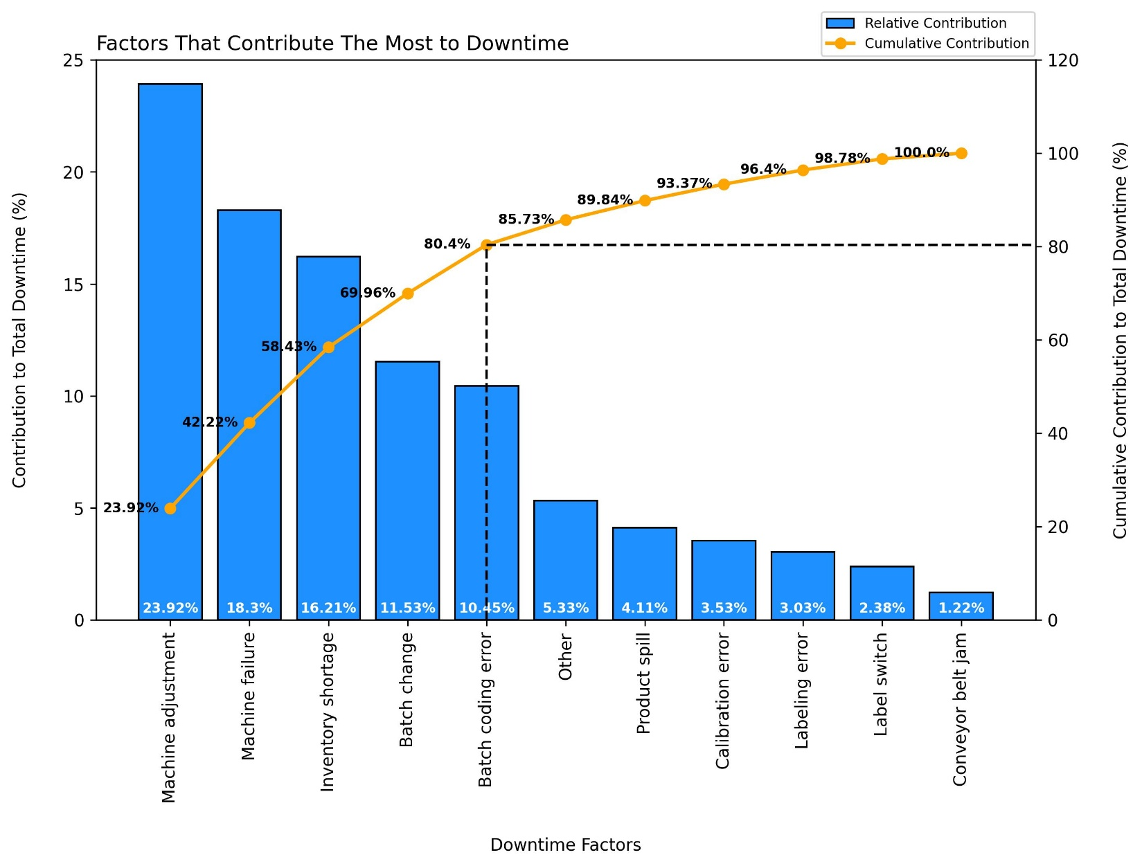

Figure : Pareto diagram depicting factors that contribute to downtime the most (generated using Python)

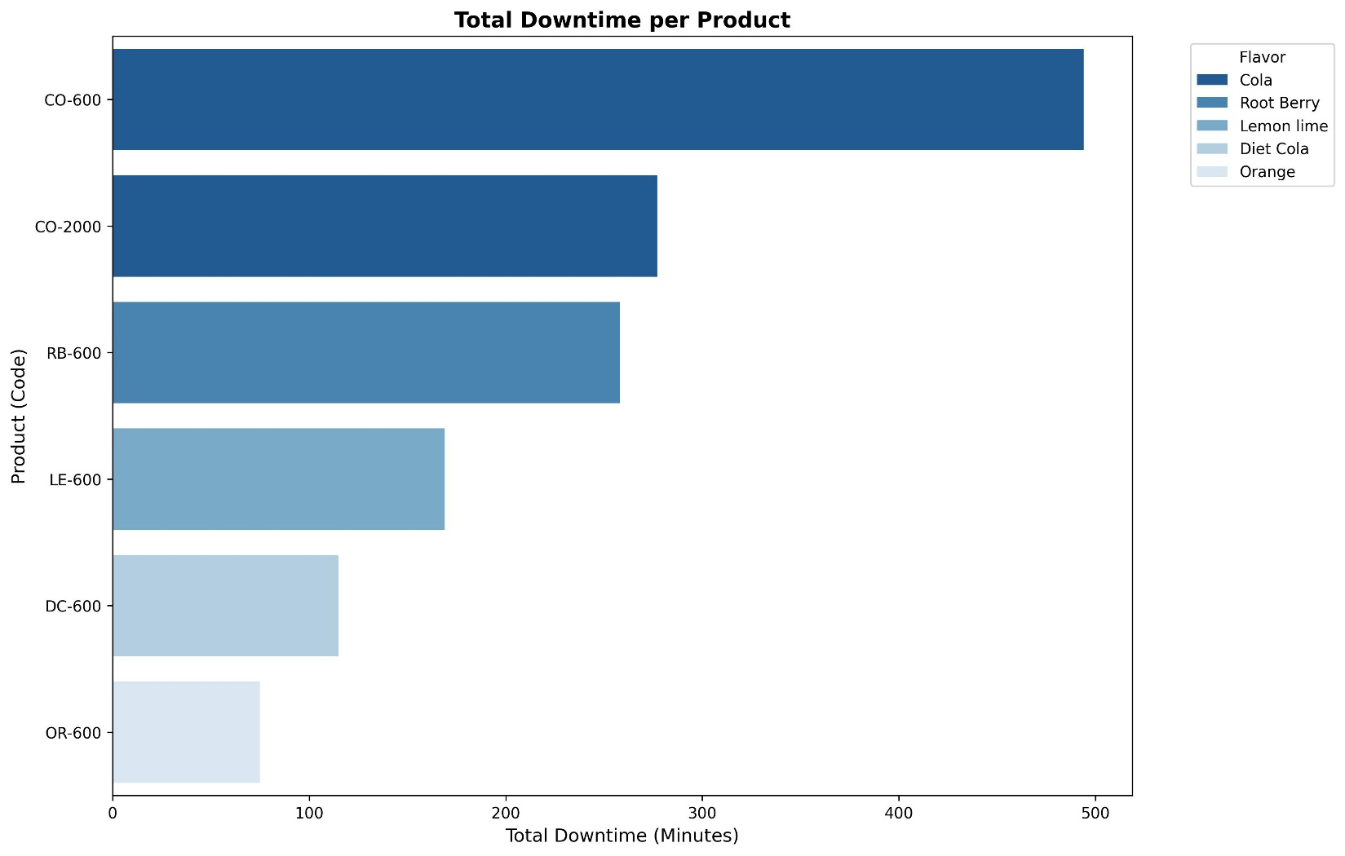

Figure : A horizontal bar depicting downtime by different products (generated using Python)

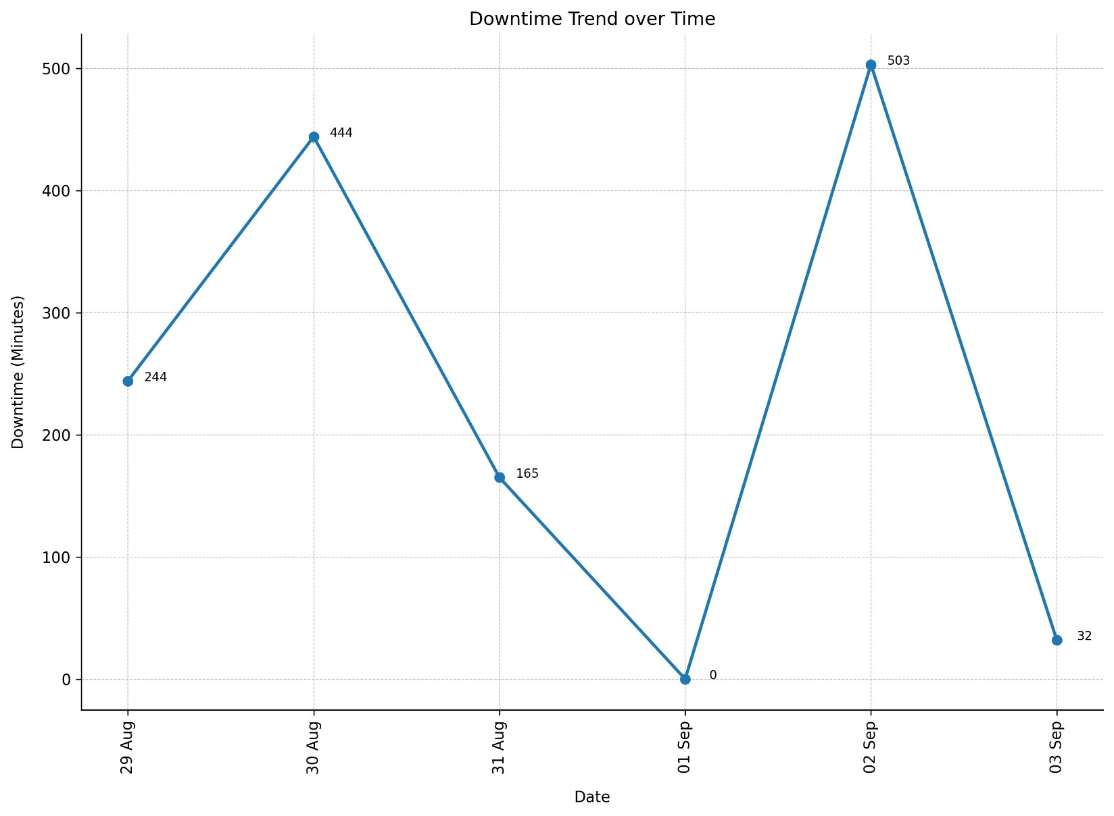

Figure : A line chart depicting time trend in downtime (generated using Python)

## Appendix II: Tableau Dashboard Screenshots



Figure : Tableau dashboard for downtime cause analysis



Figure : Tableau dashboard for time-series analysis of downtime